BEETIFY

Software Development Plan

Version <1.0>

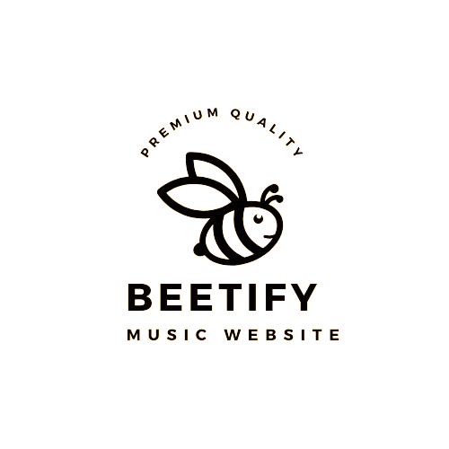

Table of Contents

**1.** **Introduction 4**

**2.** **Project Overview 4**

*2.1* *Project Purpose, Scope, and Objectives 4*

*2.2* *Assumptions and Constraints 4*

*2.3* *Project Deliverables 4*

**3.** **Project Organization 4**

*3.1* *Organizational Structure 4*

*3.2* *Roles and Responsibilities 4*

**4.** **Management Process 4**

*4.1* *Project Estimates 4*

*4.2* *Project Plan 4*

4.2.1 Phase and Iteration Plan 5

4.2.2 Releases 5

*4.3* *Project Monitoring and Control 5*

4.3.1Risk Management 5

4.3.2Configuration Management 6

Software Development Plan

# 

# Introduction

Beetify is an online music streaming application built with CSS, JavaScript (JS), and JSX. Beetify provides a great music listening experience for users with a user-friendly and easy-to-use interface.

# Project Overview

## Project Purpose, Scope, and Objectives

The purpose of the Beetifly project is to develop a music streaming platform that provides users with free access to a vast library of songs sourced from the Spotify API. The primary objective is to create a user-friendly and engaging platform that offers a seamless music listening experience, while also leveraging the capabilities of the Spotify API to ensure a diverse and extensive collection of songs across various genres and artists.

## Assumptions and Constraints

* Project has a fixed schedule of 3 weeks
* Project has 4 people, there will be no more people added during the project
* Zero-budget project

## Project Deliverables

1. Tools to create UML for the project: draw.io, Visual Paradigm, StarUML
2. Tools to create visual, UI/UX for the project: figma
3. Tools to create source code for the project: Visual Studio Code, SQL

# Project Organization

## Organizational Structure

Team Lead: V.Quang Dũng

Developer: Ng. Đỗ Hải Duy, Ng.H.Hoàng, V.Q.Dũng

Business Analyst: Võ Quang Dũng, Ng. Ngọc Phú

Tester: Ng. Ngọc Phú, Ng. Huy Hoàng

## Roles and Responsibilities

|  |  |
| --- | --- |
| ***Person*** | ***Role*** |
| *Võ Quang Dũng , Business Analyst*  *Nguyễn Ngọc Phú, Business Analyst*  *Nguyễn Ngọc Phú, Tester*  *Nguyễn Huy Hoàng, Tester*  *Nguyễn Đỗ Hải Duy, Developer*  *Nguyễn Huy Hoàng, Developer*  *Võ Quang Dũng, Developer*  *Võ Quang Dũng, Team leader* |  |

# Management Process

## Project Estimates

1. **Project Phases:**
   1. *Requirement Analysis:* 1 week
   2. *Software Design:* 2 weeks
   3. *Software Implementation*: 4 weeks
   4. *Software Testing:* 2 weeks
   5. *Deployment and Maintenance:* Ongoing
2. **Estimated Cost:**
3. *Requirement Analysis:* Minimal cost for initial planning.
4. *Software Design*: Moderate cost for UI/UX design and database structuring.
5. *Software Implementation:* Substantial cost for web and mobile platform development, database setup.
6. *Software Testing:* Moderate cost for testing efforts and bug fixing.
7. *Deployment and Maintenance:* Ongoing cost for deployment and regular maintenance.
8. **Basis of Estimates:**
9. *Past Projects:* Analysis of similar projects for cost and time estimation.
10. *Technological Requirements:* Evaluation of technology stack and development tools.
11. *Resource Availability:* Consideration of available workforce and expertise.
12. **Re-estimation Points:**
13. *During Requirement Analysis:* If new features are added or requirements change significantly.
14. *During Software Implementation*: If complexities arise, impacting the timeline or cost significantly.

## Project Plan

### Phase and Iteration Plan

***Phases:***

* ***Phase 1: Requirement Analysis***

*Start Date:* 15/01/2024

*End Date:* 22/01/2024

*Objectives:* Gather and analyze software requirements, outline project scope.

* ***Phase 2: Software Design***

*Start Date:* 24/01/2024

*End Date:* 07/02/2024

*Objectives:* Design UI/UX, database schema, and overall software architecture.

* ***Phase 3: Software Implementation***

*Start Date: 20/02/2024*

*End Date:* 25/03/2024

*Objectives:* Develop software components for web and mobile platforms, implement database functionality.

* ***Phase 4: Software Testing***

*Start Date:* 25/03/2024

*End Date:* 30/03/2024

*Objectives:* Test software features in various scenarios, address any identified issues.

* ***Phase 5: Deployment and Maintenance***

*Start Date:* 31/03/2024

*End Date:* Ongoing

*Objectives:* Deploy the software, provide ongoing maintenance, and updates.

***Iterations:***

1. ***Iteration 1:*** Requirement Gathering
2. ***Iteration 2:*** UI/UX Design
3. ***Iteration 3:*** Database Design
4. ***Iteration 4:*** Web Platform Development
5. ***Iteration 5:*** Mobile Platform Development
6. ***Iteration 6:*** Software Testing
7. ***Iteration 7:*** Deployment and Maintenance

### Releases

1. ***Release 1:*** Beta Version for Internal Testing
2. ***Release 2:*** Demo Version for Client Presentation
3. ***Release 3:*** Final Release for Production Use

## Project Monitoring and Control

### Risk Management

|  |  |  |  |  |  |  |
| --- | --- | --- | --- | --- | --- | --- |
| *Risk ID* | *Risk Description* | *Probability* | *Impact* | *Risk Exposure (=Probability * Impact)* | *Priority* | *Mitigation Strategy or Contingency Plan* |
| *R1* | *Competition* | *50%* | *100%* | *50%* | *3* | *Since the world already have music software like Spotify, Soundcloud, Apple Music,… Our solution is to keep maintenance and upgrade if possible, also make something unique compared to other softwares.* |
| *R2* | *API doesn’t working* | *50%* | *100%* | *50%* | *1* | *In case the Spotify API doesn’t work and we can’t port music from it to our music software, our backup plan is to use existing music data which contain 100+ song.* |
| *R3* | *Copyright striked* | *10%* | *23%* | *2.3%* | *2* | *Cooperate with the copyright owner or delete the song.* |

### Configuration Management

* Github for managing our project source code and any file related
* Google Drive, Discord, Messenger for storing and sharing documents of the project